Contents:

- Server Requirements
- Basic Site Configuration
- Security
- Database Connections and Linking
- Errors and Fixes
- Revision History

Server Requirements

- Install Software for server:
  - Access 2003
  - IIS Server
  - Microsoft .NET Framework Version 2.0 Redistributable Package
  - ASP.NET AJAX Extensions 1.0 (http://asp.net)
- Copy “SANDS” folders and files to server

Basic site Configuration

- Use the IIS Administrative Tool to configure to configure the “SANDS” folder as a web application. Here is a screenshot of this step on an XP PRO machine:
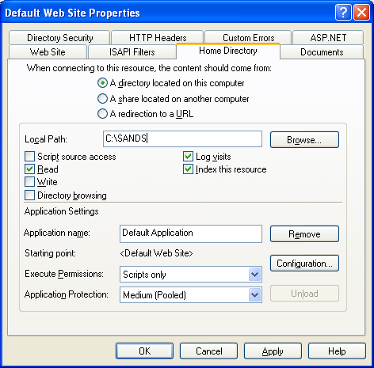
- Set default document to : Default.aspx

Security
Two user’s names are used for permissions:
- “Internet Guest Account”
  - IUSR_servername
- “ASPNET process”
  - servername\ASPNET

First
- On the top level sands folder
- Set both “ASP.NET Machine Account” & “Internet Guest Account” to Read & Execute
- These properties should be inherited for all sub objects
- 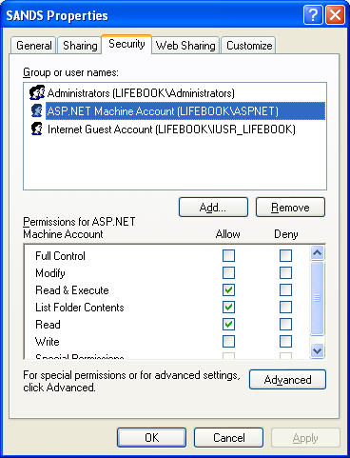

Second
- Set Security on “App_Data”.
- Set both “ASP.NET Machine Account” & “Internet Guest Account” To Modify
  - Otherwise, when a database is opened locally on the server, the “file already in use” error will occur to browsers.
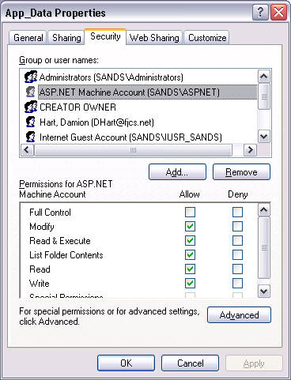

Database Connections and Linking

ODBC Connection
- Using the Administrative Tool > ODBC Data Source Administrator, create a System DSN to the Clientele SQL Server. This connection is used for importing parts and model information to SANDS.mdb.
- 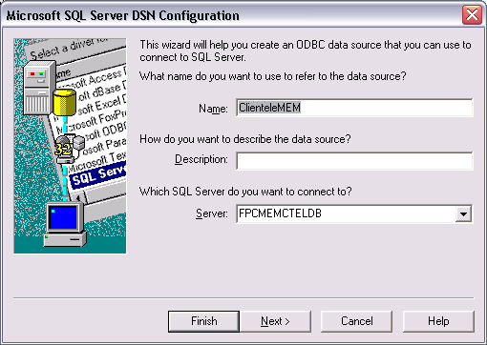

Access Linking
Several of the Access Databases link to each other. This was done to keep the entities separate and the number of tables in a single database to a minimum. The links between databases must be updated whenever they are moved.
- Use the MS Access Linked Table Manager to validate/change links in these files:
- App_Data/SANDS.mdb
- App_Data/SilverStream.mdb
- App_Data/LookUpTableDB.mdb

Errors and Fixes

- Exception message: Could not use ''; file already in use.’
  - Close any open database files on the local server
  - Set Security to allow modification by the “ASP.NET Machine Account” and the “Internet Guest Account”
- Exception message: “D:\SANDS\App_Data\xxx.mdb' is not a valid path. Make sure that the path name is spelled correctly and that you are connected to the server on which the file resides.”
  - Links within the Access Databases are not working correctly. Open the Databases and check the Linked Table Manager
- Exception message: Operation must use an updateable query.
  - Set permissions on the database file so that both “ASP.NET Machine Account” and “Internet Guest Account” can modify the file.

Revision History

Revision | Date | Author | Remarks
1.1 | 20080725 | dhart | Added ODBC information
1.0 | 20080717 | dhart | Initial doc

